**PATUAKHALI SCIENCE AND TECHNOLOGY UNIVERSITY**



Course Code: CCE-112

**SUBMITTED TO:**

# Dr. Md Samsuzzaman Sobuz

**Department of Computer And Communication Engineering Faculty of Computer Science And Engineering**

**SUBMITTED BY:**

Name:Sadman Hafiz Shuvo

ID: 2102021, Registration No: 10148

Faculty of Computer Science and Engineering

**Date of submission: 28-2-2023**

## Assignment 2

**Program**

A program is a set of instructions that a computer follows in order to preform a particular task.

It tells computer what to do . The medium which enables us to express our views and feelings is

Language . We need a language that a computer can undertand . It has to be given instructions for every action.

**Coding**

Coding, sometimes called computer programing. It is the process of assigning a code to something for classification or identification. It also can be described as the process or activity of writing computer program.

**Programmer**

Programmer is a person who writes computer program. Or else a programmer is someone who writes/creates computer software or applications by providing a specific programming language to the computer.

**Programming language**

A programming language is a system of notation for writing computer programs. Programming languages are text-based formal language. But they may also be graphical. They are a kind of computer language.

### The 5 basic coding concepts :

**1.Run:**

Running a program means to execute it or to make it performs its specialized task. this can be done by clicking on a program’s icon, typing a command into a terminal or command prompt, or by running the program within an integrated development environment.

**2.Algorithm:**

An algorithm is a set of instructions for solving a problem or accomplishing a specific task. It is essentially a step by step process that outlines the actions that need to be taken in order to achieve a particular goal.

**3.Script:**

A script is a program that is written in a scripting language such as Python, Javascript, or Ruby. Scripts are typically shorter and less complex than full-fledged programs, and they are often used for automating repetitive tasks or for performing simple calculation.

**4.Function:**

A function is a block of code that performs a specific task or set or tasks. Functions can be used to organize code and make it more modular, allowing you to reuse code in multiple places throughout your program.

**5.Operators:**

Operators are the symbols or keywords used in programming to perform specific operations on data. For example, the plus sign (+) is an operator used to add two numbers together, and the equal sign (=) is an assignment operator used to assign a value to a variable.

### Scratch Programming

**Definition:**

Scratch programming is a visual programming language developed by the lifelong kindergarten group at the Massachusetts institute of technology (MIT) Media lab.

**What Scratch Do:**

Scratch allows users to create interactive stories, animations, games, and other creative projects by dragging and dropping blocks of code instead of typing text-based code. Users can create code blocks to control the movements and actions of characters, and can add sounds and graphics to create and interactive experience. Scratch also includes a large online community where users can share their projects and collaborate with others on programming projects.

**How to install Scratch :**

First of all we need to download this application from browser. Here is the link : <https://scratch.mit.edu/download> .You need to click on **Direct download** to download this file. This is the Scratch icon below:

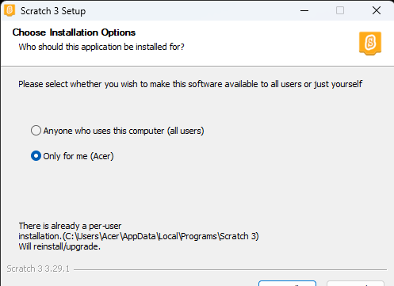

After download this software double click on this icon. After clicking the icon this interface will Show up:

Then click on **install** and scratch will take a few second and installation will complete. Than click on the **finish** bar. That’s all. The Scratch has been installed.

…………….